**Project Report**

**1. INTRODUCTION**

1.1 Project Overview

1.2 Purpose

**2. LITERATURE SURVEY**

2.1 Existing problem

2.2 References

2.3 Problem Statement Definition

**3. IDEATION & PROPOSED SOLUTION**

3.1 Empathy Map Canvas

3.2 Ideation & Brainstorming

3.3 Proposed Solution

3.4 Problem Solution fit

**4. REQUIREMENT ANALYSIS**

4.1 Functional requirement

4.2 Non-Functional requirements

**5. PROJECT DESIGN**

5.1 Data Flow Diagrams

5.2 Solution & Technical Architecture

5.3 User Stories

**6.PROJECT PLANNING & SCHEDULING**

6.1 Sprint Planning & Estimation

6.2 Sprint Delivery Schedule

6.3 Reports from JIRA

**7. CODING & SOLUTIONING (Explain the features added in the project along with code)**

7.1 Feature 1

7.2 Feature 2

7.3 Database Schema (if Applicable)

**8. TESTING**

8.1 Test Cases

8.2 User Acceptance Testing

**9. RESULTS**

9.1 Performance Metrics

**10. ADVANTAGES & DISADVANTAGES**

**11. CONCLUSION**

**12. FUTURE SCOPE**

**13. APPENDIX** Source Code

GitHub & Project Demo Link

|  |  |  |
| --- | --- | --- |
| Date | 17th November 2022 | |
|  |  | |
| Team ID | PNT2022TMID53479 | |
|  |  | |
| Project Name | Project - Corporate Employee Attrition Analytics | |
|  |  | |
| Team Members | Team Lead - Kesav S J | |
|  | Team Member 1 | - Koushik K |
|  | Team Member 2 | -Deekshitha M |
|  | Team Member 3 | - Giridhar Prashanth |
|  |  |  |

**INTRODUCTION**

The two primary components that contribute to the development and growth of the nation are corporate businesses and industries. Manpower, often known as the workforce, is a crucial component of any corporation. Performance and expansion of the business depend on how long the employees stay in their jobs. The fundamental difference between attrition and retention is that each has a different aim, but they are fundamentally related since one clears the way for the other. Global marketplaces are getting more competitive over time, which has altered workplace culture. The existence of the labor force, the emerging imbalance between the supply and demand of competent workers, and the growing importance of work-life balance have made it difficult for the company's HR and management to find the right candidate for the right role. The two faces that reflect the approach to determine business employment trends, general business growth, motivation, and growth are attrition and retention. Because losing a valuable employee has a negative impact on knowledge value, uneasy coworkers lost capital, and the organization's reputation, it is observed that globally competitive organizations spend a significant amount of interest, time, and money on employee attrition. This ultimately results in the failure of the business or organization.

**1.1 PROJECT OVERVIEW**

The organization's success depends on its ability to draw in and keep outstanding personnel. Identifying the factors that retain employees at the organisation and those that cause others to quit is a crucial responsibility for HR. A number of data points about the personnel who are either still employed by the firm or have left it are included in the data. To stop the company from losing talented employees, it is important to recognise and address these problems.

**1.2 PURPOSE**

* 1. To analyze the factors that causes the employee attrition through predictive analysis and to give suggestions by modelling techniques to reduce the cause of retention.

* 1. Visualization Charts are prepared to highlight the insights for the given dataset

* 1. Creating dashboard for the HR and managers for understanding the reasons for attrition and to take necessary measures in the organization.

**2. LITERATURE SURVEY**

Reduction in the number of employees in a company is referred to as employee attrition. Employee attrition has been a recognised problem for the corporate sector during the past twenty years. Employees depart from the company for a variety of reasons. Among the causes include the need for high pay, changes in technology or roles, obstacles in the workplace, etc. High attrition increases the cost of various company characteristics and functions. The overall cost to the employees is increased by recruitment, training, and development expenses.

**2.1 EXISTING PROBLEM**

Both the employer and the employee have recently lost faith in one another. The former believes that an employee can quit the company at any moment, whereas the latter believe that the former can dismiss the employee at any time. Regardless of who is at fault, a loss of workers is unavoidable. Attrition refers to

this labor loss, regardless of the cause. Attrition is a prevalent issue in any organization, regardless of the kind of business or organizational structure, which not only hinders output and results in high long-term expenses and a loss of goodwill to the organisation. Therefore, it becomes necessary to investigate this complex issue and find workable answers.

**2.2 REFERENCES**

1. **TITLE**: From Big Data to Deep Data to Support People Analytics for Employee Attrition Prediction.

**YEAR**: 2021

**AUTHORS**: Nesrine Ben Yahia; Jihen Hlel; Ricardo Colomo-Palacios

**DESCRIPTION**: In the era of data science and big data analytics, firms and their HR managers can reduce attrition by using people analytics, which transforms how businesses and their human resources (HR) managers find and keep talent. Staff attrition is a big problem for businesses in this situation since it affects both production and the continuity of planning. The main contributions that this study has made in this situation are listed below. We start by proposing a people's The analytics approach to employee attrition prediction shifts from a large data environment to a deep data one by focusing on data quality rather than quantity.

2. **TITLE**: Towards Understanding Employee Attrition using a Decision Tree Approach

**YEAR**: 2019

**AUTHORS**: Saadat M Alhashmi

**DESCRIPTION**: The severe issue of employee attrition has been the subject of research for several decades. This problem has been approached using a variety of methods, including psychological studies and exit interviews. The goal is to prevent or minimise employees leaving a company before hiring a replacement. Recently, researchers in the field of artificial intelligence have also addressed this problem due to the amount of data. With the aid of publicly available data and a decision tree approach, this study tackled the problem of staff attrition. The results of this work-in-progress study are encouraging, and subsequent work-studies will add more factors and test the model using data from a nearby supermarket.

3. **TITLE**: Employee Attrition System Using Tree Based Ensemble Method

**YEAR**: 2022

**AUTHORS**: Vimoli Mehta; Shrey Modi

**DESCRIPTION**: Around the world, employee churn has grown to be a serious issue. The loss of the best personnel is one of the major problems that company owners deal with in their organisations. A competent employee is always a benefit to the company, and when they leave, it can cause a number of issues, including financial losses, performance declines, and knowledge loss. In addition, compared to recruiting new personnel, hiring new workers is far more expensive, time-consuming, and labor-intensive. It takes a long time to find a new employee because it takes him months to get trained and get used to the surroundings. Therefore, commercial organisations must take advantage of emerging trends and technology that uses machine learning algorithms. Companies can reduce this loss by knowing the cause of staff churn before it happens. Using the dataset "IBM HR Analytics Employee Attrition Performance" and the tree-based Ensemble Machine Learning Model, this article offers a thorough analysis of employee attrition. The decision of an employee to quit the company is connected to a number of statistically important factors. To acquire the best outcomes from the currently available tree approaches, the study assesses the tree-based ensemble.

4. **TITLE**: Early Prediction of Employee Attrition using Data Mining Techniques

**YEAR**: 2019

**AUTHORS**: Sandeep Yadav; Aman Jain; Deepti Singh

**DESCRIPTION**: Take away our best 20 employees, and we [Microsoft] become a mediocre firm, according to a comment attributed to Bill Gates. Bill Gates' comment brought our attention to one of the main issues with employee churn in the workplace. Any firm must pay a hefty price for employee attrition (turnover), which could ultimately affect how efficiently it operates as a whole. According to CompData Surveys, total turnover climbed from 15.1 percent to 18.5 percent over the previous five years. Finding a qualified and experienced employee is a difficult endeavour for any firm, and replacing such workers is even more difficult. In addition to raising the major cost of human resources (HR), this has an effect on an

organization's market worth. Despite these realities, the literature that has contributed to numerous misunderstandings between HR and employees receives little attention. As a result, the purpose of this study is to present a methodology for predicting employee churn by applying classification algorithms to analyse the particular behaviours and qualities of the employee.

5. **TITLE**: Prediction of Employee Attrition Using data mining

**YEAR**: 2018

**AUTHORS**: R. Shiva Shankar; J. Rajanikanth; V.V. Sivaramaraju; K.V.S.S.R. Murthy

**DESCRIPTION**: Employee attrition has recently grown to be a significant issue in enterprises. Employee attrition is a significant problem for firms, particularly when skilled, technical, and critical people leave for another company that offers greater opportunities. As a result, replacing a skilled person costs money. As a result, we examine the frequent causes of employee attrition using data on both present and historical employees. On the human resource data, we employed well-known classification algorithms, such as Decision tree, Logistic Regression, SVM, KNN, Random Forest, and Naive Bayes, in order to reduce employee attrition. To do this, we apply the feature selection approach to the data and analyse the outcomes to stop staff attrition. The ability to foresee employee turnover helps businesses expand economically by lowering the cost of their human resources

**2.3 PROBLEM STATEMENT DEFINITION**

**Problem Statement**

Employees are the most important part of an organization. Successful employees meet deadlines, make sales, and build the brand through positive customer interactions. Employee attrition is a major cost to an organization and predicting such attritions is the most important requirement of the Human Resources department in many organizations. In this problem, our task is to predict the attrition rate of employees in an organization. Among all employee-related problems, employee attrition is one of the key problems in today's scenario despite the changes in the external environment. Attrition is said to be a gradual

reduction in the number of employees through resignation, death, and retirement. A high attrition rate indicates that the employees have a lot of issues with the organization. Consequently, they'll only spread the bad word about the company. This will pose a huge risk to the company's reputation and make it difficult for the employer to find the right replacements. Every organization wants its valuable employees to be a part of its organization for a long period. Still, when many employees start leaving, it will be a concern for the organization. The key to success for any organization is attracting and retaining top talent. One of the key tasks is to determine which factors keep employees at the company and which prompt others to leave. It’s more cost-effective to keep the employees a company already has. • A company needs to maintain a pleasant working atmosphere to make their employees stay in that company for a longer period. To reduce the cost of attrition, organizations need to ensure that employees’ aspirations are met.

**Business Model/Impact**

• Organizations can use this tool to manage the team. • Reduction in Hiring Cost

**3. IDEATION & PROPOSED SOLUTION**

**3.1 EMPATHY MAP CANVAS**

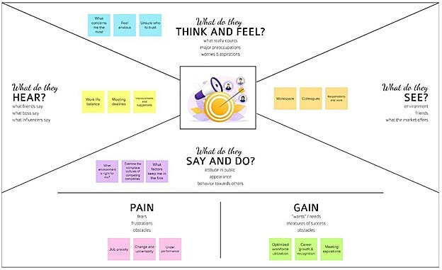

**3.2 IDEATION AND BRAINSTORMING**

**1)Collection of Ideas**

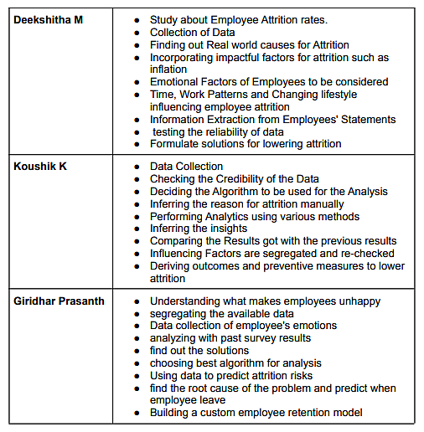

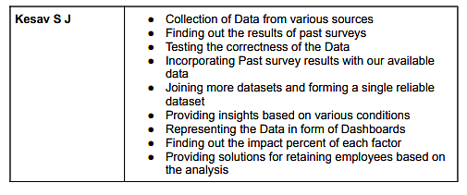

**2) Grouping of ideas**

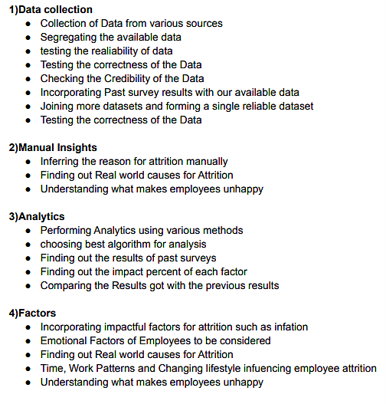

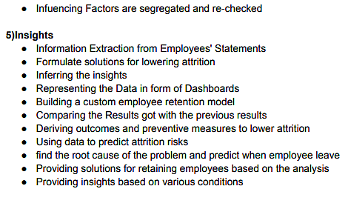

**3) Prioritization**

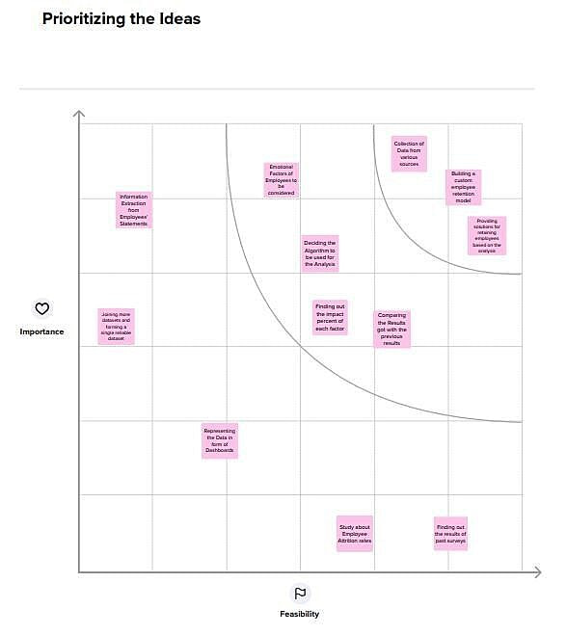

|  |  |  |  |
| --- | --- | --- | --- |
|  |  |  | |
| **3.3 PROPOSED SOLUTION** | |  |  |
|  |  |  |  |
| **S.No.** | **Parameter** | **Description** |  |
|  |  |  |
|  |  |  |  |
| 1. | Problem Statement (Problem to be | Losing productive people would directly affect |  |
|  | the growth of any organization. Given the data |  |
|  | solved) | of employees working or resigned, the task is to |  |
|  |  | analyse the data and find out the factors which |  |
|  |  | lead the employees to leave the organization. |  |
|  |  | This will help in retaining the employees and |  |
|  |  | reduce the attrition rates. |  |
|  |  |  |  |
| 2. | Idea / Solution description | Based on the results of the analysis of |  |
|  | employee attrition, improving on the factors |  |
|  |  | that lead the employees to leave the |  |
|  |  | organization, maintaining good relationship |  |
|  |  | with the employees and promoting personal |  |
|  |  | career growth would have a positive impact on |  |
|  |  | the retention of employees. |  |
|  |  |  |  |
| 3. | Novelty / Uniqueness | Analysing the given data along with external |  |
|  | survey results obtained from employees |  |
|  |  | directly. This will help in improving the |  |
|  |  | accuracy of the results. |  |
|  |  |  |  |
| 4. | Social Impact / Customer Satisfaction | Reduction in the loss of valuable employees |  |
|  | could be achieved. The Software directly |  |
|  |  | benefits the customer by providing insights on |  |
|  |  | the specific factors which need to be improved. |  |
|  |  | The above factors subsequently lead to the |  |
|  |  | growth of the company as well as customer |  |
|  |  | satisfaction. |  |
|  |  |  |  |
| 5. | Business Model (Revenue Model) | We plan to implement this application using a |  |
|  | subscription-based model. Based on the number |  |
|  |  | of employees, the subscription plans may differ. |  |
|  |  |  |  |
| 6. | Scalability of the Solution | This software will be scalable for any |  |
|  | organization as it runs only on the particular |  |
|  |  | company’s employee dataset. Implementing |  |
|  |  | this software with the help of cloud service |  |
|  |  | providers helps in increasing the scalability. |  |
|  |  |  |  |

**3.4 PROBLEM SOLUTION FIT**

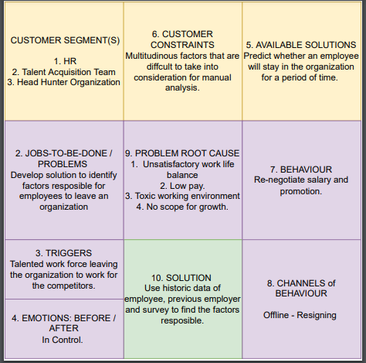

**4. REQUIREMENT ANALYSIS**

**4.1 FUNCTIONAL REQUIREMENTS**

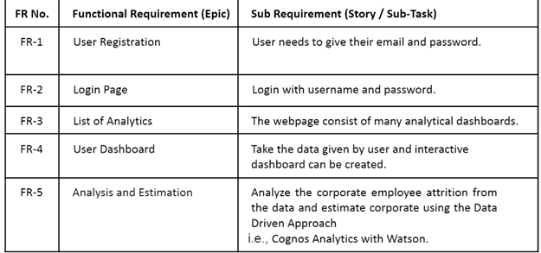

**4.2 NON FUNCTIONAL REQUIREMENTS**

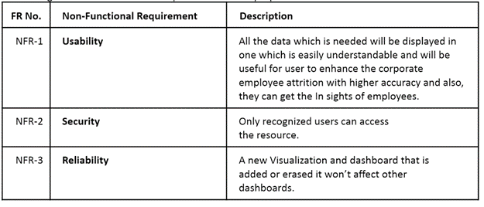

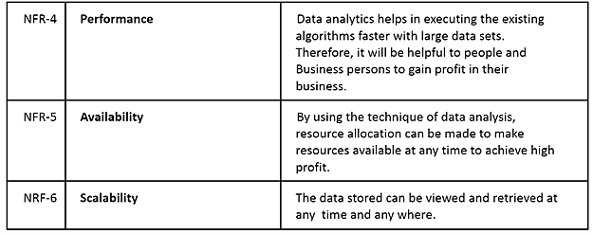

**5. PROJECT DESIGN**

**5.1 DATA FLOW DIAGRAMS**

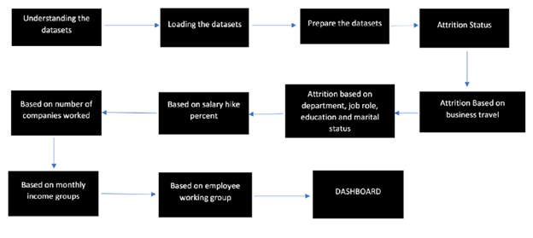

**5.2 SOLUTION & TECHNICAL ARCHITECTURE**

1. The Process involves cleaning the input dataset first.

1. Datasets are from various sources including the given one, plus the survey results obtained from employees
2. Data preprocessing is then done to remove all unnecessary or unstructured data and also to make it structured ▪ After Pre-processing, using a machine learning algorithm (Supervised learning), we are classifying the common factors leading to attrition.
3. Also, the prediction of future attrition rates is projected with the available data ▪ Finally, the output is displayed to the user

**Solution Architecture**

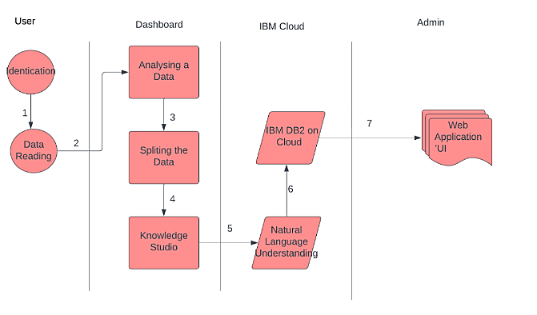

**5.3 USER STORIES**

|  |  |  |  |  |  |  |  |
| --- | --- | --- | --- | --- | --- | --- | --- |
| **User Type** | **Functional** | **User** | **User Story /** |  | **Acceptance** | **Priority** | **Release** |
|  | **Requirement** | **Number** | **Task Story** |  | **criteria** |  |  |
|  | **(Epic)** |  |  |  |  |  |
|  |  |  |  |  |  |  |
|  |  |  |  | |  |  |  |
| Customer | Registration | USN-1 | As a CEO, I can register | | I can access my | High |  |
| (CEO) |  |  | for the application by | | account |  | Sprint- |
|  |  |  | entering my email, | | /dashboard |  | 1 |
|  |  |  | password, and confirming | |  |  |  |
|  |  |  | my password. |  |  |  |  |
|  |  |  |  | |  |  |  |
| Customer |  | USN-2 | As an employee, I can | | I can access my | High |  |
| (Employee) |  |  | register for the application | | account/dashbo |  | Sprint- |
|  |  |  | by entering | my mail, | ard |  | 1 |
|  |  |  | password,and | confirming |  |  |  |
|  |  |  | password. |  |  |  |  |
|  |  |  |  | |  |  |  |
|  |  | USN-3 | As a user, I can register | | I can register & | Medium | Sprint-2 |
|  |  |  | for the application | | dashboard |  |  |
|  |  |  |  |  | with login |  |  |
|  |  |  |  | |  |  |  |
| Customer | Login | USN-4 | As a user, I can log into | | I can access my | High |  |
| (CEO) |  |  | the application by | | account/ |  | Sprint- |
|  |  |  | entering email & | | dashboard |  | 3 |
|  |  |  | password |  |  |  |  |
|  |  |  |  |  |  |  |  |

|  |  |  |  |  |  |  |
| --- | --- | --- | --- | --- | --- | --- |
| Customer |  | USN-5 | As a user, I can log into | I can access my | High |  |
| (Employee) |  |  | the application by | account |  | Sprint- |
|  |  |  | entering email and | /dashboard |  | 3 |
|  |  |  | password. |  |  |  |
|  |  |  |  |  |  |  |
| CEO | Dashboard | USN-6 | As a CEO, I can use the | I can view the | HIgh |  |
|  |  |  | predict button to know | visual chart. |  | Sprint- |
|  |  |  | which factor keeps the |  |  | 4 |
|  |  |  | employee at the company |  |  |  |
|  |  |  | and which prompts others |  |  |  |
|  |  |  | to leave. |  |  |  |
|  |  |  |  |  |  |  |
| Employee |  | USN-7 | As an employee of the | I can see the | High |  |
|  |  |  | organization, I can view, | acknowledgeme |  | Sprint- |
|  |  |  | fill and submit the | nt message for |  | 4 |
|  |  |  | survey form that is | submitting the |  |  |
|  |  |  | displayed. | survey |  |  |
|  |  |  |  |  |  |  |

**6. PROJECT PLANNING & SCHEDULING**6

**6.1 SPRINT PLANNING & ESTIMATION**

|  |  |  |  |  |  |  |
| --- | --- | --- | --- | --- | --- | --- |
| **Sprint** | **Functional** | **User** | **User Story / Task** | **Story** | **Priority** | **Team Members** |
|  | **Requirement** | **Story** |  | **Points** |  |  |
|  | **(Epic)** | **Numbe** |  |  |  |  |
|  |  | **r** |  |  |  |  |
| Sprint-1 | Dashboard | USN-1 | As a user, I give the details | 5 | High | Kesav S J |
|  |  |  | of the employees working |  |  | Koushik K, |
|  |  |  | in our organization for the |  |  | Deekshitha M, |
|  |  |  | attrition detail. |  |  | Giridhar Prashanth |
| Sprint-1 |  | USN-2 | As an Analyst, I will | 3 | High | Kesav S J |
|  |  |  | check the dataset and |  |  | Koushik K, |
|  |  |  | perform exploratory data |  |  | Deekshitha M, |
|  |  |  | analysis in Cognos |  |  | Giridhar Prashanth |
|  |  |  | Analytics |  |  |  |
| Sprint-2 | Report | USN-3 | As a user, I want Simpler | 2 | Low | Kesav S J |
|  |  |  | limited number of |  |  | Koushik K, |
|  |  |  | visualizations that report a |  |  | Deekshitha M, |
|  |  |  | particular event |  |  | Giridhar Prashanth |
| Sprint-2 |  | USN-4 | As an Analyst, I will use | 3 | Medium | Kesav S J |
|  |  |  | Cognos Analytics to |  |  | Koushik K, |
|  |  |  | generate a report |  |  | Deekshitha M, |
|  |  |  |  |  |  | Giridhar Prashanth |
| Sprint-3 | Story | USN-5 | As a user, I can only | 3 | Medium | Kesav S J |
|  |  |  | understand the Analysis in |  |  | Koushik K, |
|  |  |  | animated presentation of |  |  | Deekshitha M,  Giridhar Prashanth |

|  |  |  |  |  |  |  |  |  |  |  |  |  |  |  |
| --- | --- | --- | --- | --- | --- | --- | --- | --- | --- | --- | --- | --- | --- | --- |
|  |  |  |  |  |  |  | | | | | | | | |
| Sprint-3 | |  | USN-6 | | As an Analyst, I use | |  | 3 |  |  | Medium | Kesav S J  Koushik K | | |
|  |  |  |  |  | Cognos Analytics to create | |  |  |  |  |  | Deekshitha M | | |
|  |  |  |  |  | an animated presentation | |  |  |  |  |  | Giridhar Prashanth | | |
|  |  |  |  |  | (Story) of the dataset | |  |  |  |  |  |  | | |
| Sprint-4 | | Predictive | USN-7 | | As a user, I want to predict | |  | 5 |  |  | Medium | Kesav S J  Koushik K | | |
|  |  | Analysis |  |  | the attrition rate of the | |  |  |  |  |  | Deekshitha M | | |
|  |  |  |  |  | company from the dataset | |  |  |  |  |  | Giridhar Prashanth | | |
|  |  |  |  |  |  |  |  |  |  |  |  |  | | |
| Sprint-4 | |  | USN-8 | | As an Analyst, I will | |  | 3 | |  | High | Kesav S J  Koushik K | | |
|  |  |  |  |  | perform Prediction | |  |  |  |  |  | Deekshitha M | | |
|  |  |  |  |  | Analysis by utilizing | |  |  |  |  |  | Giridhar Prashanth | | |
|  |  |  |  |  | various libraries in python | |  |  |  |  |  |  | | |
| **6.2 SPRINT DELIVERY SCHEDULE** | | | | |  |  |  |  |  |  |  |  |  |  |
|  |  |  |  |  |  |  | |  |  |  | |  |  |  |
| **`Sprint** |  | **Total** | **Duration** |  | **Sprint Start** | **Sprint** | |  |  | **Story Points** | |  | **Sprint** |  |
|  |  | **Story** |  |  | **Date** | **End Date** | |  |  | **Completed (as** | | | **Release** |  |
|  |  | **Points** |  |  |  | **(Planned)** | |  |  | **on Planned** | |  | **Date** |  |
|  |  |  |  |  |  |  |  |  |  | **End Date)** | |  | **(Actual** |  |
|  |  |  |  |  |  |  |  |  |  |  |  |  | **)** |  |
| Sprint-1 |  | 5 | 6 Days |  | 24 Oct 2022 | 29 Oct 2022 | |  |  | 5 | |  | 29 Oct 2022 |  |
|  |  |  |  |  |  |  | |  |  |  | |  |  |  |
| Sprint-2 |  | 5 | 6 Days |  | 31 Oct 2022 | 05 Nov 2022 | |  |  | 5 | |  | 05 Nov 2022 |  |
|  |  |  |  |  |  |  | |  |  |  | |  |  |  |
| Sprint-3 |  | 5 | 6 Days |  | 07 Nov 2022 | 12 Nov 2022 | |  |  | 5 | |  | 12 Nov 2022 |  |
|  |  |  |  |  |  |  | |  |  |  | |  |  |  |
| Sprint-4 |  | 5 | 6 Days |  | 14 Nov 2022 | 19 Nov 2022 | |  |  | 5 | |  | 19 Nov 2022 |  |
|  |  |  |  |  |  |  |  |  |  |  |  |  |  |  |

We have a 6-day sprint duration, and the velocity of the team is 5 (points per sprint). To calculate the team’s average velocity (AV) per iteration unit (story points per day)

**AV = SPRINT DURATION/VELOCITY**

**= 6/5**

**= 1.2**

**6.3 REPORTS FROM JIRA**



**7. CODING & SOLUTION**

**7.1 - FEATURE 1**

In this project , we have done visualization by considering several criterias like

➤ age

➤ gender

➤ department

➤ business travel

➤ number of companies worked

➤ monthly income, etc.

Considering all this during the visualization process makes it more accurate to

exactly identify the root caue for the attrition of the employees.

**7.2 FEATURE 2:**

The dataset is also understood by various factors to consider the missing or

unnecessary values in it. Python is used inorder to make the process quite easy and

visualisation is also performed using python.Random forest classifier is used in training and testing the datasets which yields almost 97% of accuracy

**Interactions and Correlations**

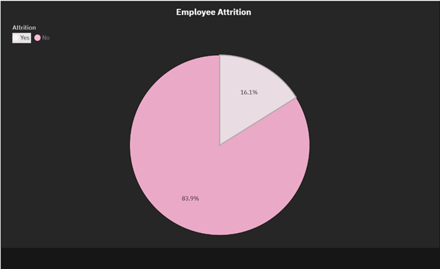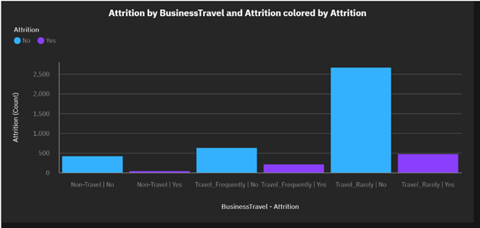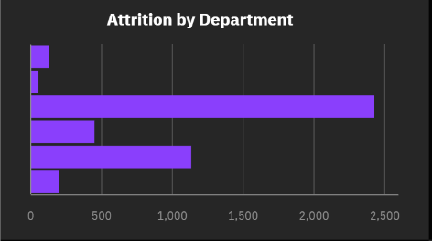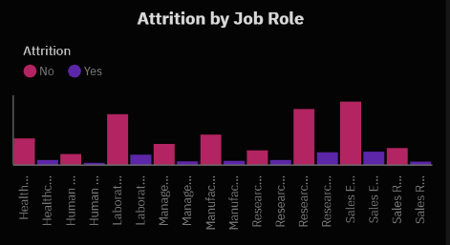

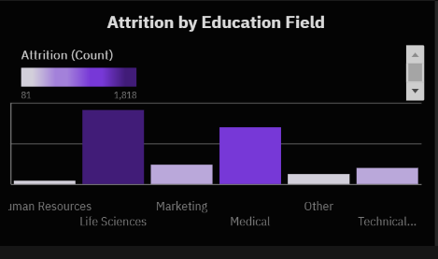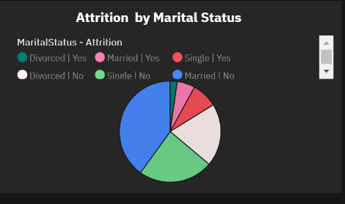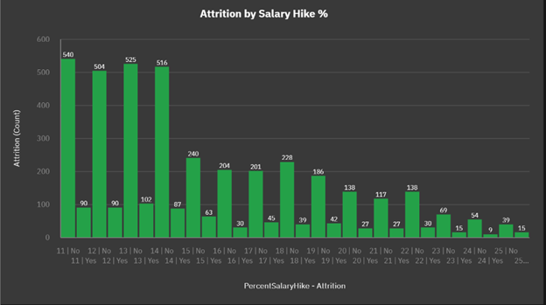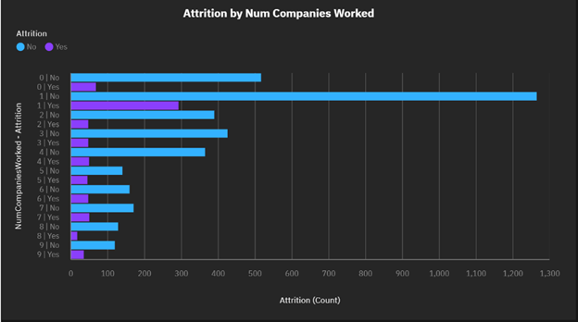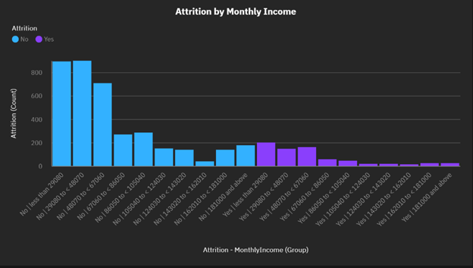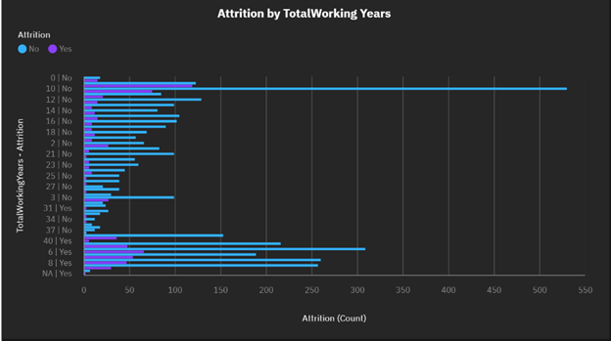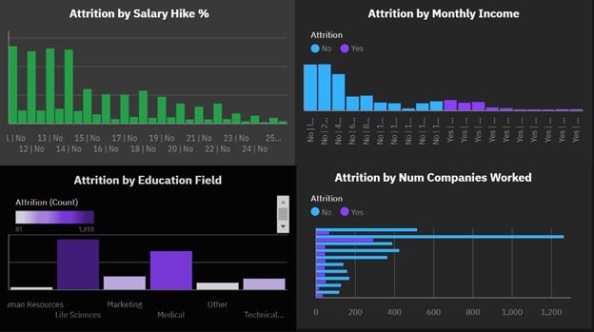

**8. TESTING**

**8.1** **TEST CASES**

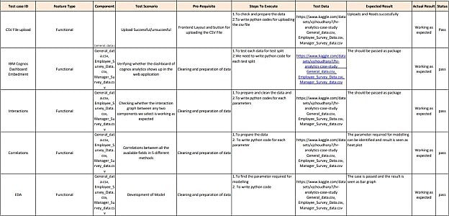

**8.2** **USER ACCEPTANCE TESTING**

**Defect Analysis**

This report shows the number of resolved or closed bugs at each severity level, and how they were resolved

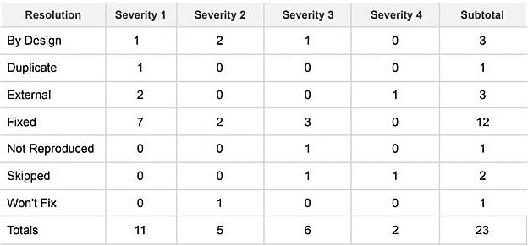

**Test Case Analysis**

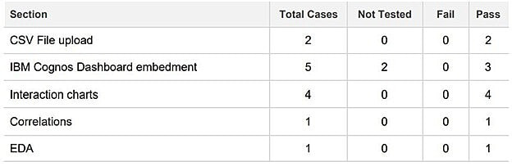

**9. RESULTS**

**9.1 PERFORMANCE METRICS:**

1. Attrition status by age :

➤ visualization performed by column chart

➤ Age by status = 92%

2. Employee count by department :

Visualization performed by bar chart

Employee count by department wise

➤ Human resource = 17%

➤ R&D = 89%

➤ Sales = 60%

3. Attrition based on business travel :

Visualization performed by waterfall chart percentage by business travel

➤ Non-travel =25%

➤ Travel frequently =75%

➤ Travel rarely =35%

➤ Sum=100%

4. Attrition based on department ,job role ,education &marital status:

Visualization performed by line & column chart percentage by

Department wise

i. Human resource =15%

ii. R&D =85%

iii. Sales =45%

iv. Education =69%

v. Job role =100%

vi. Marital status

➤ Male =80%

➤ Female =20%

5. Attrition based on salary hike percentage :

➤ Visualization performed by pie chart

➤ Salary hike percentage (overall) =95%(based on department wise)

6. Based on No.of companies worked:

Visualization performed by stocked column chart

No. of companies worked based on attrition

i. Human resource =15%

ii. R&D =65%

iii. Sales =35%

7. Visualization based on monthly income groups :

Visualization performed by scatterplot chart

➤ Monthly income percentage = 100%

8. Prediction based on employee working groups :

Visualization performed by network chart employee working groups

➤ percentile =75%

DASHBOARDS:

1. Attrition based on department by age department (visualization

performed by bar chart)

➤ Human resource =17%

➤ R&D =89%

➤ SALES =60%

➤ OVERALL =91%

2. Analysis based on job involvement in daily rate :

Visualization performed by heat plot chart job involvement

➤ percentage =99%

3. Based on attrition :

➤ Visualization performed by scatterplot

➤ Attrition percentage =66%

➤ Business travel =99%

4. Calculating the employee performance :

Visualization performed by column chart

➤ No.of companies worked =59%

➤ Performance rating =84%

**10. ADVANTAGES & DISADVANTAGES**

**Advantages:**

1.Higher manpower cost

2.Stronger employee relationships

3.Setting a culture right

4.High performance

5.Improve employee satisfaction

6.Increased productivity

7.Increased Revenue

8.Morale improvement

**Disadvantages:**

1.Lack of knowledgeable people

2.Decreased overall performance

3.Poor work life balance

4.Create a negative image

5.Huge risk on company reputation

**11.CONCLUSION**

The following suggestion are given based on the analysis and modeling result:

**CURRENT EMPLOYEES:**

•Work life balance should be improved

•Work environment should be improved

•The manager of an employee should not be changed very often

•Employees should be provided relevant training regularly, especially for its younger employees

**FUTURE EMPLOYEES (CHANGES IN HIRING PROCESS):**

The company should follow either one of the strategies given below –

•Hire older people with decent work experience

•Hire young people and train them appropriately

**12. FUTURE SCOPE**

The future scope of the research is that these analysis and modeling helps in forecasting the cause of employee disengagement, enables HR managers develop long-term strategies to reduce attrition, Competitive measures to enhance company brand image, Develops and shapes drills that benefit both the management and the employees. The scope of this research can be extended to many numbers of samples and to other working fields other than corporations.

**13. APPENDIX**

Nowadays, employee attrition has become a serious issue regarding a company’s competitive advantage. It’s very expensive to find, hire and train new talents. It’s more cost-effective to keep the employees a company already has. A company needs to maintain a pleasant working atmosphere to make their employees stay in that company for a longer period. A few years back it was done manually but it is an era of machine learning and data analytics. Now, a company’s HR department uses some data analytics tool to identify which areas to be modified to make most of its employees stay.

**Source code:**

# -*- coding: utf-8 -*-

"""corporate employee attrition analytics.ipynb

Automatically generated by Colaboratory.

Original file is located at

https://colab.research.google.com/drive/15UEJzaJpCsT7FtqqrsY8xUU_PpdObUUK

"""

#Description: This program predicts employee attrition

#Import the libraries

import numpy as np

import pandas as pd

import seaborn as sns

# load the data

from google.colab import files

uploaded = files.upload()

#Store the data int a dataframe

df = pd.read_csv('WA_Fn-UseC_-HR-Employee-Attrition.csv')

#Print the first 100 rows

df.head(100)

#Get the rows and columns

df.shape

#Get the column data types

df.dtypes

# Get a count of the empty values of each column

df.isna().sum()

#Check for any missign or null vlues in the data

df.isnull().values.any()

# View some statistics

df.describe()

#Get a count of the number of employee that stayed and left the company

df['Attrition'].value_counts()

#Visualize the number of employees that stayed and left the company

sns.countplot(df['Attrition'])

#Checking the accuracy

print((1233-237)/1233)

#Show the number of employees that left and stayed by age

import matplotlib.pyplot as plt

plt.subplots(figsize=(12,4))

sns.countplot(x='Age',hue='Attrition',data=df,palette='colorblind')

#Print all of the datatypes and their unique values

for column in df.columns:

if df[column].dtype == object:

print(str(column) + ' : ' + str(df[column].unique()))

print(df[column].value_counts())

print('_____________________________')

#Removing some unnecessary columns

df=df.drop('Over18',axis=1)

df=df.drop('EmployeeNumber',axis=1)

df=df.drop('StandardHours',axis=1)

df=df.drop('EmployeeCount',axis=1)

#Get the corelation

df.corr()

#Visualize the corelation

plt.figure(figsize=(14,14))

sns.heatmap(df.corr(),annot=True,fmt= '.0%')

#Transform the data

#Transform non-numerical into numerical columns

from sklearn.preprocessing import LabelEncoder

for column in df.columns:

if df[column].dtype == np.number:

continue

df[column] = LabelEncoder().fit_transform(df[column])

#Create a new column

df['Age_Years'] = df['Age']

#Drop the age column

df = df.drop('Age',axis=1)

#Show the data frame

df

#Split the data

X = df.iloc[:,1:df.shape[1]].values

Y = df.iloc[:,0].values

#Split the data into 75% training and 25% testing

from sklearn.model_selection import train_test_split

X_train, X_test,Y_train, Y_test =train_test_split(X,Y, test_size = 0.25,random_state=0)

# Use the Random forest classifier

from sklearn.ensemble import RandomForestClassifier

forest = RandomForestClassifier(n_estimators=10,criterion='entropy',random_state=0)

forest.fit(X_train,Y_train)

#Get the accuracy on the training dataset

forest.score(X_train,Y_train)

#Show the confusion matrix and accuracy score for the model on the test data

from sklearn.metrics import confusion_matrix

cm= confusion_matrix(Y_test,forest.predict(X_test))

TN=cm[0][0]

TP=cm[1][1]

FN=cm[1][0]

FP=cm[0][1]

print(cm)

print('Model testing Accuracy = {}'.format((TP+TN) / (TP+TN+FN+FP)))

**Github** - <https://github.com/IBM-EPBL/IBM-Project-17384-1659662477>

**Demo-** <https://drive.google.com/file/d/1xBJv9yXhm8IVU2fZ92jCn4fGdD40_oDW/view?usp=share_link>